Accela Ad hoc Reporting - HELP

**Lydia Lim’s cheatsheet – For internal Accela use only**

Turn on *Navigation Pane* to see table of contents (Menu Bar > View > Navigation Pane)

AHR = Ad Hoc Reporting

Information in this cheatsheet is generally organized by AHR tabs (shown as uppercase Heading 1 items in Navigation Pane)

# History / Features Added

* Accela Ad Hoc Reporting is a third-party software provided by Izenda (http://www.izenda.com)
* Ad Hoc Reporting was added to AA in 7.2 FP2 (4th Qtr 2012?). Announced/demo’ed at 2012 User Conference.
* ASI (templates) Feature released in 7.2 FP2 Hotfix 7 (Jan 2013)
* ASIT templates added in 7.3.
* Form Designer tool added in 7.3.
  + See *Ad hoc Reporting Form Designer Help.docx* for info on using Form Designer.

# ASI, ASIT, Custom Attributes

* See [**Templates**](#_TEMPLATES_(ASI,_TSI,)

# Cross-Tab / Matrix Report

* Use *Add Pivot* button in **Fields** tab
* See ASI Testing.doc
* See Also IMPREF > Testing > Workflow Pivot

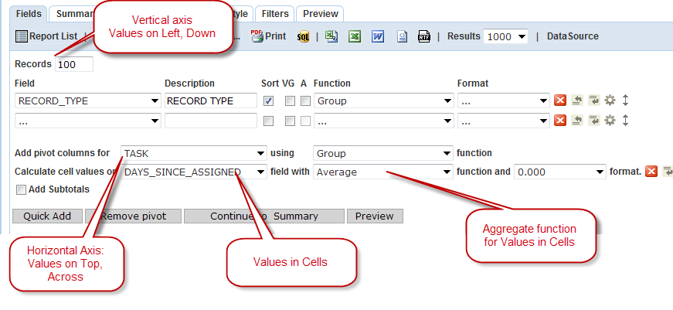

* --> Resulting Output:  
  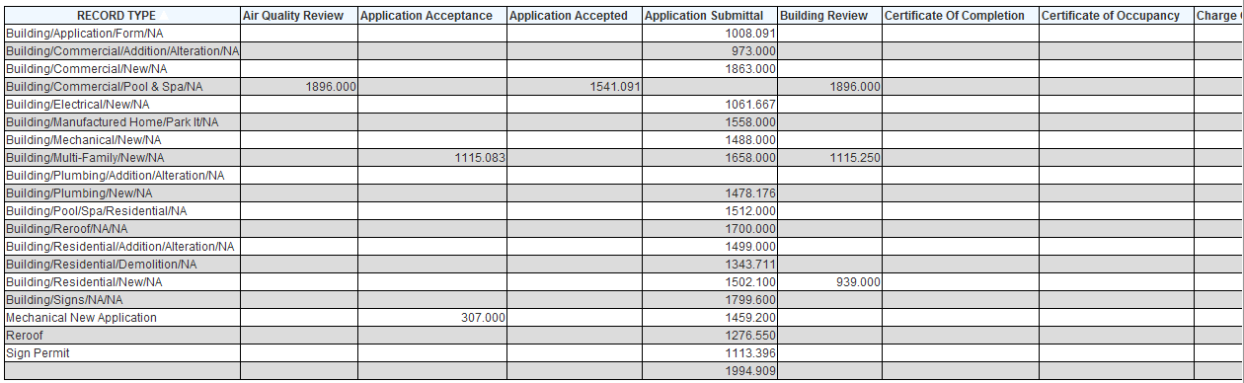

## Cell Value FUNCTION options

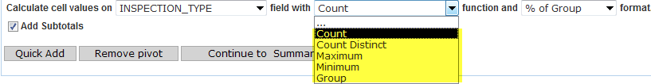

## Cell Value FORMAT options

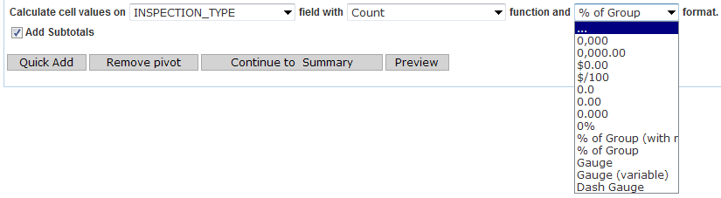

Example of **% of Group:** (Group 100% is total for column)  
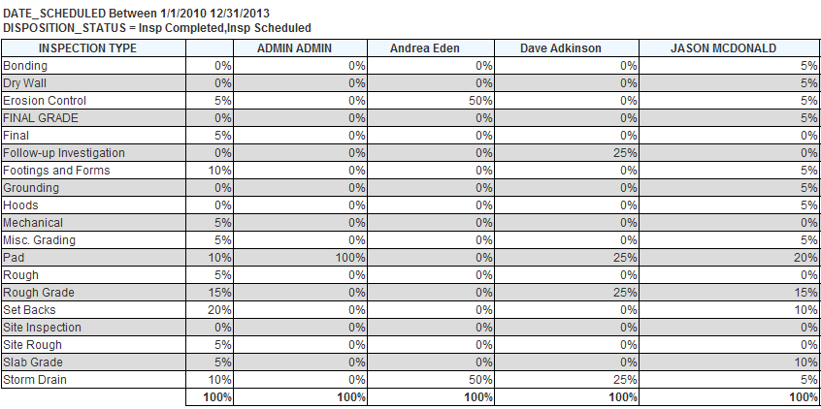

# CHART tab

## Pie Chart

* Show Value Label = Summary value (as specified by Value: Function) is displayed with each slice
* Show Slice Labels = Group name (as specified by Label field) is displayed with each slice

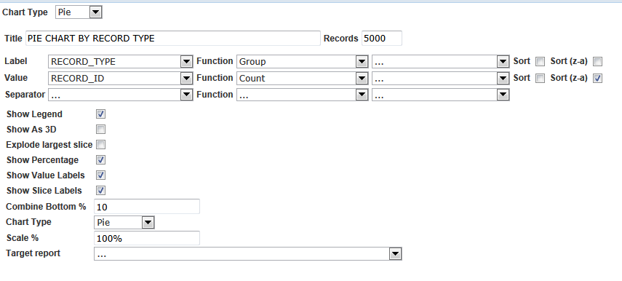

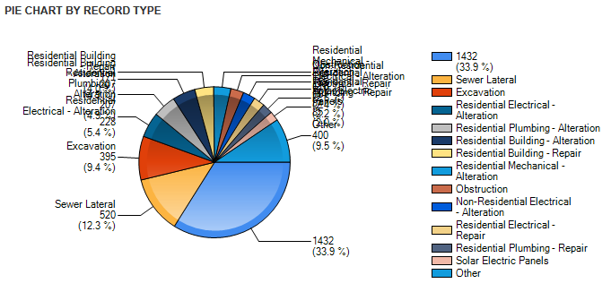

# DATA SOURCE tab

## DB View Relationship

* Used to specify joins between two or more views.

## Join

* When a second view is selected, the DB View Relationships pane appears below Data Sources  
  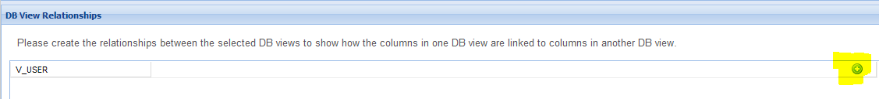
* **AA 7.2:** If multiple views are selected, RECORD_ID join is required between views. If you join by a different field (not RECORD_ID) and click *Add Fields* to proceed, AHR does nothing. No error message appears.
  + **Cannot add config view like V_USER or V_STANDARD_CHOICE with transaction VIEW**
* **AA 7.3:**
  + Allows joins between transaction table and configuration table (not RECORD_ID join), e.g. V_RECORD.UPDATED_BY = V_USER.USER_ID  
    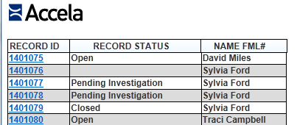
  + Appears to require join by RECORD_ID between transaction tables. If you join by a different field (not RECORD_ID) and click *Add Fields* to proceed, AHR does nothing. No error message appears.

### Adding 2nd Join

* Sometimes, two views need to be joined by another field in addition to RECORD_ID. Example: To pull fee payment history for a specific fee from FEE_PAYMENT_HISTORY view. The *DB View Relationships* panel allows only one join between two views.
* The 2nd join can be added in the **Filters** tab, by adding a filter that uses the **Equals (Field)** operator.   
  Example:  
  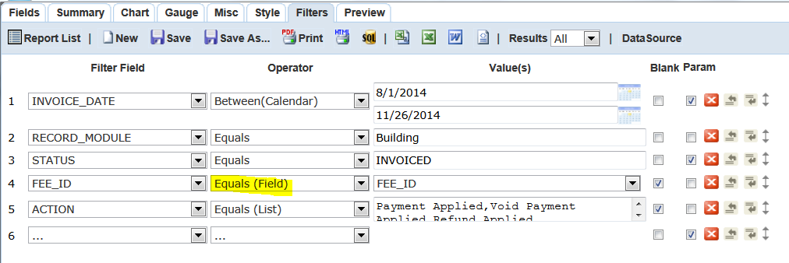
* If a **LEFT OUTER JOIN** is used, use the right view for the *Filter* field, and use the left view for the *Value* field. Check the "Blank" checkbox.
  + In the example above, FEE is left outer joined to FEE_PAYMENT_HISTORY.   
    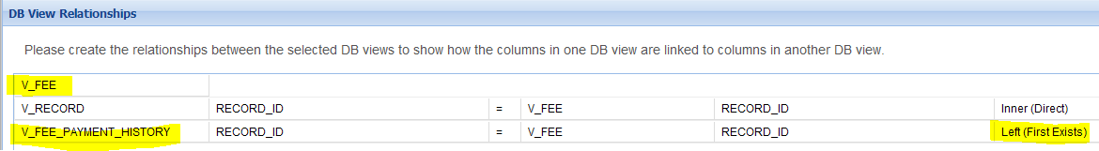
  + The filter for its 2nd join by FEE_ID is:  
    FEE_PAYMENT_HISTORY.FEE_ID Equals (Field) FEE.FEE_ID  
    ("Blank" is checked to ensure the OUTER JOIN works)
  + The resulting join in the SQL statement:  
    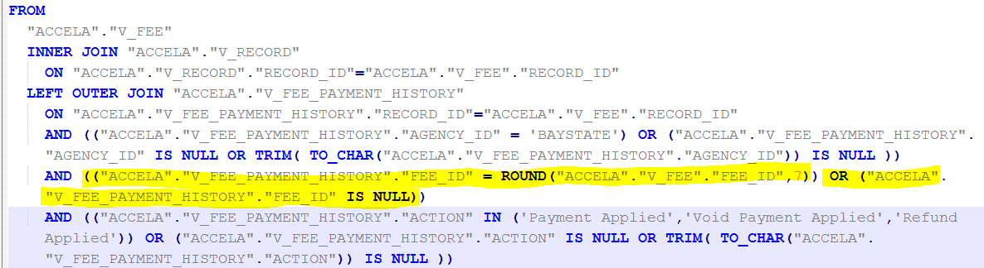

## Left Outer Join

Example of LEFT OUTER JOIN of RECORD to OWNER and PARCEL

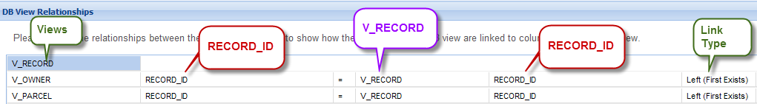

**Note**: If **filter** is needed for outer joined table (e.g. only show the "Primary" owner, but RECORD data should still appear even if there isn't a Primary owner), you MUST check the "Blank" box to the right of the filter on the **Filters** tab for the outer joined table. Example:  
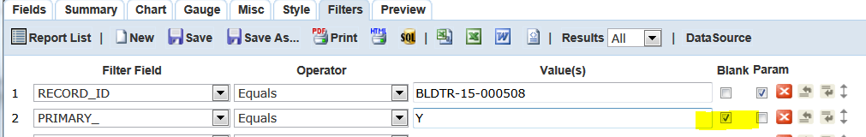

See FILTERS tab > Operator > Blank

## Left Outer Join – 2nd view to 3rd view

In the example below,

TRUST ACCT is left outer joined to TRUST ACCT TRANSACTION by TRUST ACCOUNT ID

TRUST ACCT is also left outer joined to TRUST ACCT ASSOCIATED by TRUST ACCOUNT ID

TRUST ACCT ASSOCIATED is in turn left outer joined to REF CONTACT



* + NOTE: Even though TRUST ACCT ASSOCIATED is the LEFT table in relation to REF CONTACT, it appears on the RIGHT in the 3rd join predicate above.
  + Similarly, TRUST ACCT is the LEFT table in relation to TRUST ACCT TRANSACTION and TRUST ACCT ASSOCIATED, but it appears on the right side of the 1st and 2nd join predicates above.

## Select Distinct

* Check the Distinct box for query to return distinct (unique) row values only  
  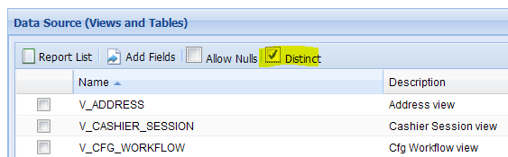
* Distinct box is checked by default. I suggest always unchecking this.

## Self Join

1. To self join a view, select the view (check its box) and add a join to the same table in the *DB View Relationships* pane.
2. Example:

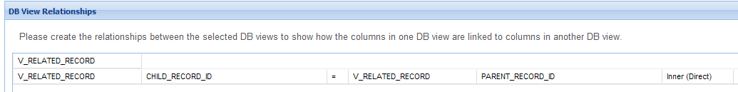

The view appears twice in the Fields dropdown, as V_RELATED_RECORD and V_RELATED_RECORD2.

## 2nd Instance of View, Adding

* It may sometimes be necessary to add a second instance of a view.
* To do so, in the first column of the DB View Relationships pane, add another row using + and select the view again from the dropdown
* Example: TRUST ACCT is joined to two instances of TRUST ACCT ASSOCIATED
  + TRUST ACCT ASSOCIATED in green is the first instance
  + TRUST ACCT ASSOCIATED in blue is 2nd instance (aliases in Fields and Filter dropdowns TRUST ACCT ASSOCIATED2)
* 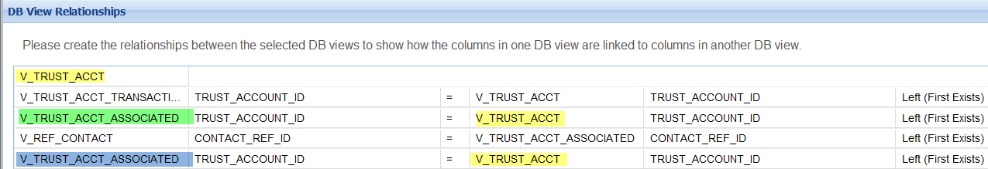
* **Note**: It isn’t possible in AHR to in turn join the second instance of a view to another view (e.g. View C). AHR joins View C to the first instance of the view.

# Subreports / Drill-downs

1. Makes use of Subreport option on the Field (Advanced Settings)
2. Limitations
   * You can only drill down using a **single filter**, because only 1 field can be defined as the drill-down filter. However, the drill-down subreport may have other hard-coded criteria.
   * In tabular reports, user must click on link for subreport data to appear.
   * Subreport data is not exported or printed with the main report data.

## STEPS:

1. Create **Subreport**
   * Identify the **field** (filter) used to pull desired values.
   * Set this **field** as the **filter** in Filter tab
   * Also set this field as the **Drill-Down Key**: Misc tab > Drill-Down Key
2. Create the main report
   * Add a **Field** that will be the *drill-down link.* This field should be the same field used as the Subreport's Drill Down Key in Step 1
     + The main report will pass this field's value to the Subreport's filter.
   * In the Field's Advanced Settings (Gear icon), choose the report created earlier as Subreport.  
     Note: Only reports that have a **Drill Down Key** specified in the **Misc** tab will appear.  
     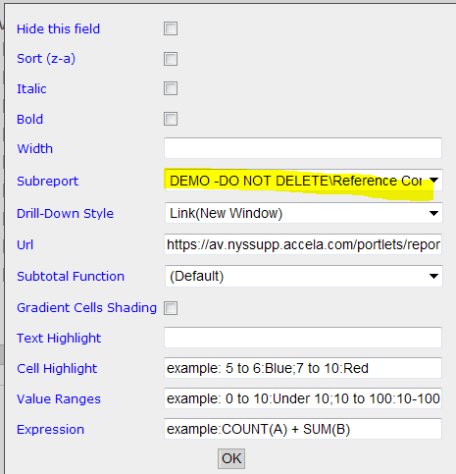
   * Choose Drill-down Style
     + Link = Subreport appears in the same window, replacing main report
     + Link (New Window) = Subreport appears in separate window
     + Embedded = Subreport embedded within main report
       - Doesn't work if subreport is too large.  
         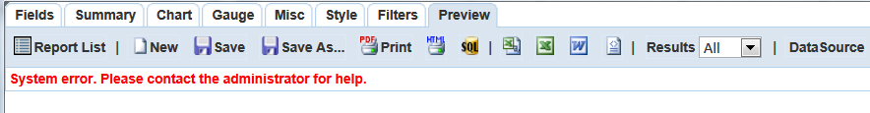
     + Popup = report pops up on top of current report
       - To close pop-up, click on it.
     + Screenshots:  
       Link (New Window):  
       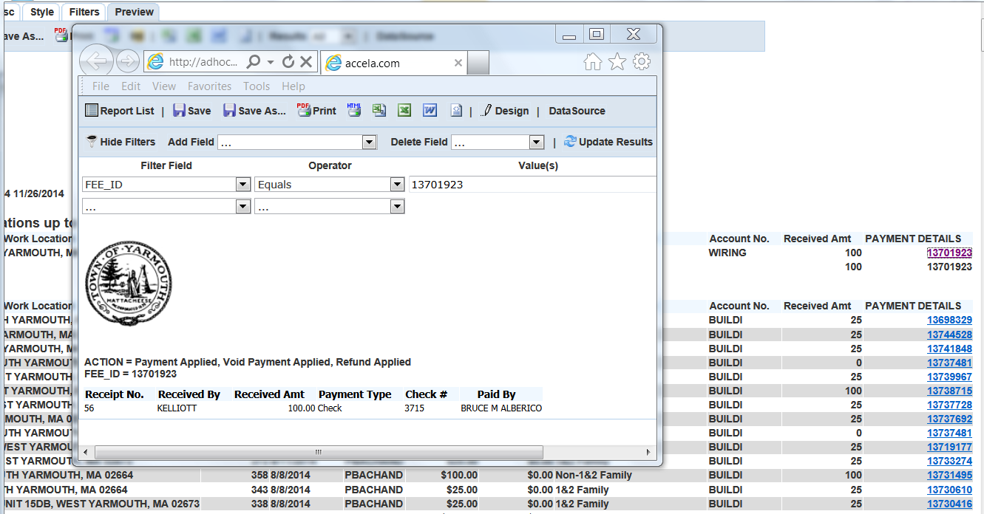

Pop-up:  
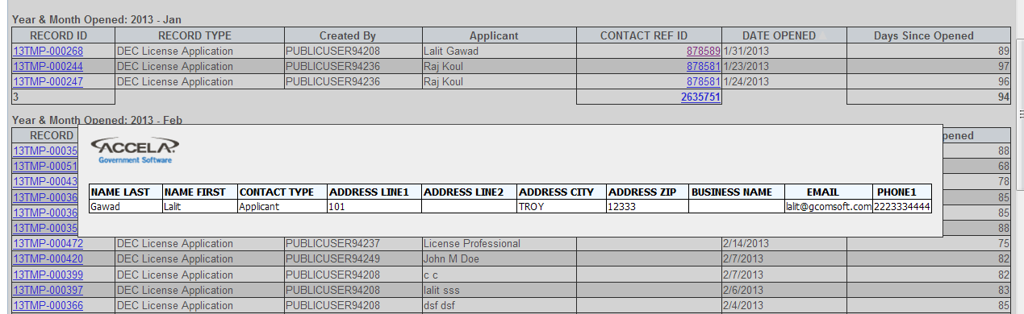

# Export Formats

* PDF, RTF, Excel, CSV, Word, OpenOffice, SQL and XML
* according to IzendaAdHocUsersGuide64

## Excel

* Excel 2010 shows error when you try to open exported .xls file, but it opens OK  
  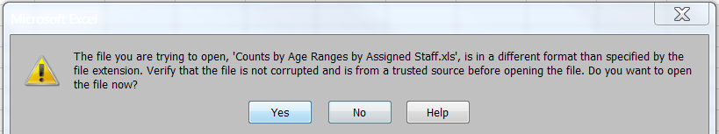
* Report Title and Description have same font size as data
* Column widths are auto-fit to contents
  + Width setting in field's Advanced Settings aren't carried into Excel export
* Bold and italic settings (Advanced Settings) are carried into Excel
* Example:  
  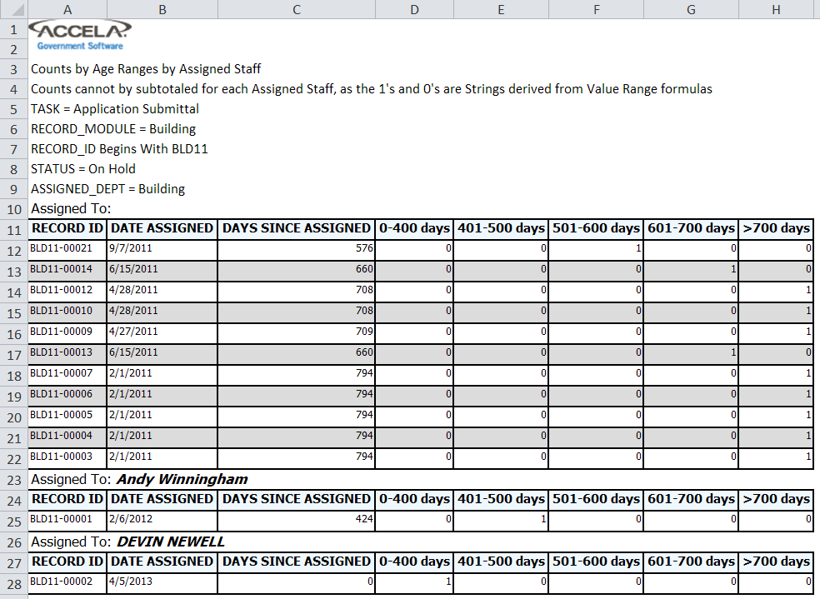

## PDF

* Columns in different groups don’t align
  + Columns width in in group auto-sizes to fit contents. Same issue whether or not “Minimize grid width” is checked in Style tab
  + Example:
  + 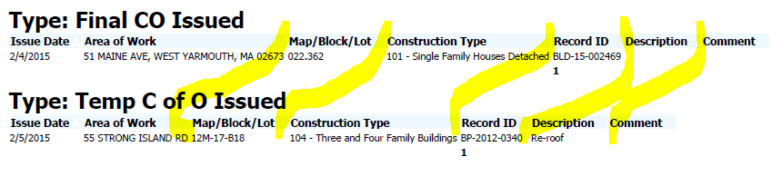
  + Columns align OK in Excel
* Export is poor: NOTE: All issues below appear to have been fixed in current version of izenda
  + Columns too narrow > contents overflow to next cell
    - * To prevent this, must set field **Width** (in pixels) in **Advanced Settings**:  
        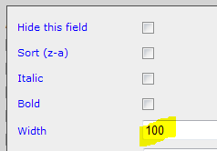
      * Or in **Style** tab, uncheck "Minimize Grid Width"
    - HTML tags for bolding and italics appear
      * To prevent this, uncheck Italic and Bold in Advanced Settings
  + Report title is large (Tahoma 20 points)  
    Counts by Age Ranges by Assigned Staff
  + Report description is large (Tahoma 20 points)Example:  
    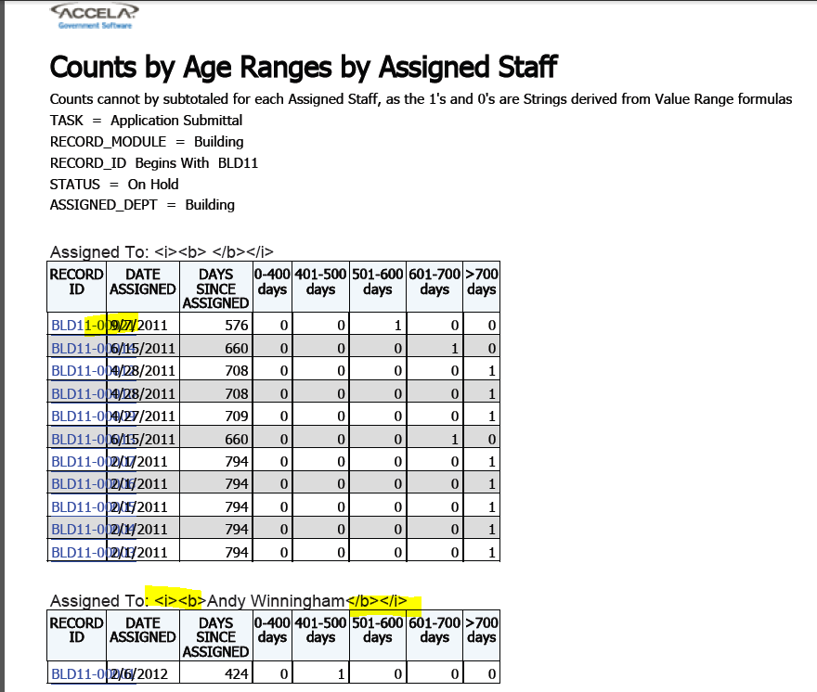
  + If Header is added and is aligned Right, this causes Title and Description to wrap on Left:  
    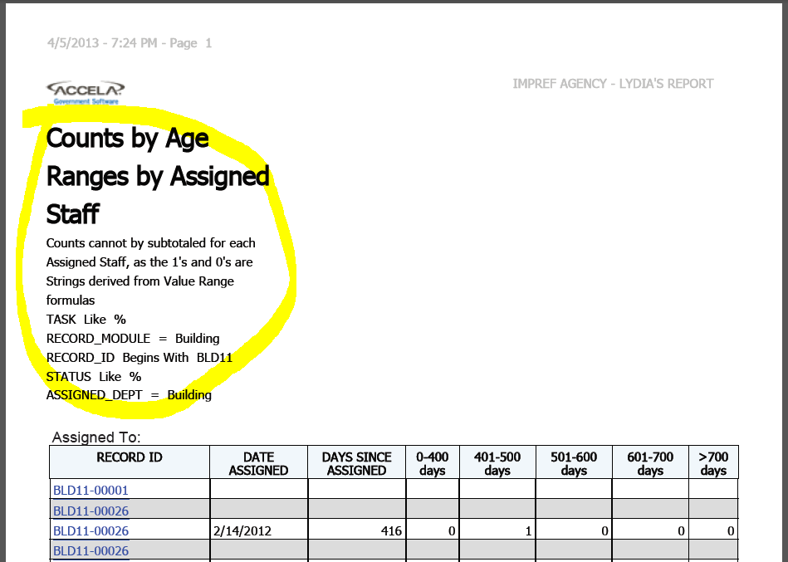

# FIELDS tab

## A checkbox

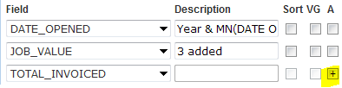

* Used to concatenate two or more character fields. See below: *Concatenate Two Character Fields*
* Used to perform basic arithmetic between two or more number fields. See below: *Arithmetic Calculation on Two fields*

## Add Pivot

* Use to create cross-tab report. See above: *Cross Tab / Matrix Report*
* Use with ASI (BCHCKBOX) view (not "Template")

## Advanced Field Settings (*Gear* icon)

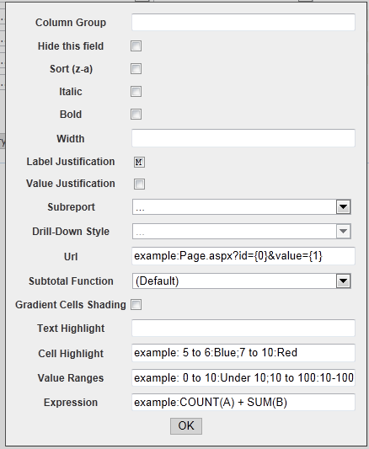

### Column Group

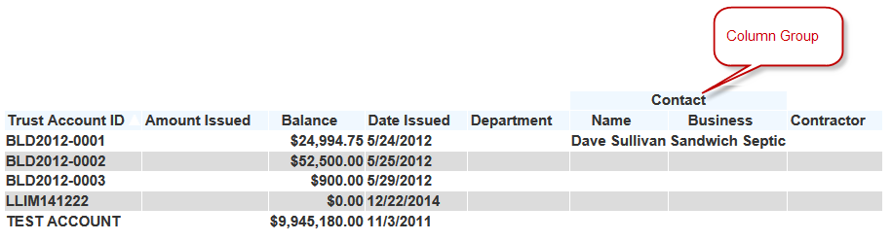

* To add a **Column Group** heading above two or more columns, enter the same Column Group name (e.g. “Contact”) for each column to be included in the column group.

### Expression

* Izenda will multiple field by # entered in Expression
  + Example: This will multiply the field value by 0.5:  
    
* If Group function is used for fields list (not VG), can use aggregation function in non-grouped field (though you must assign a function to that field - which Izenda will ignore). The Expression can reference another field in the same view (doesn't need to be in Field List)
* Cannot use number with aggregated value: Error message:  
  *Unknown field " 100000" at expression: "COUNT(INSPECTION_TYPE) * 100000"*
* Cannot add two aggregated fields. Error Message:

*Function " SUM" not allowed at expression: "SUM(MILEAGE_START) + SUM(MILEAGE_END)"*

* Cannot combine aggregated and non-aggregated field. Error message:

*ORA-00979: not a GROUP BY expression*

### URL

* Example:
* https://av.supp.accela.com/portlets/reports/adHocReport.do?mode=deepLink&reportCommand=recordDetail&altID={0}

### Value Range

* Only numeric value ranges can be specified
* Syntax: # to #:Value1; # to #:Value2; # to #:Value3
  + Example that returns 1 if value is between 401 and 500  
    0 to 400:0; 401 to 500:1; 501 to 10000:0
  + No ELSE clause
* If field value doesn't fit within range, original field value appears
* If syntax is wrong, Izenda throws error or original field value appears
* Resulting value is treated as **string** (even if Number if used as in example above)  
  and cannot itself be summed/aggregated as number.
  + If Group function is used with Sum function, Izenda shows 1st value
  + If VG (Visual Group) is used with Subtotals (Sum), Izenda sums original values, not value derived from Value Range function. Example:  
    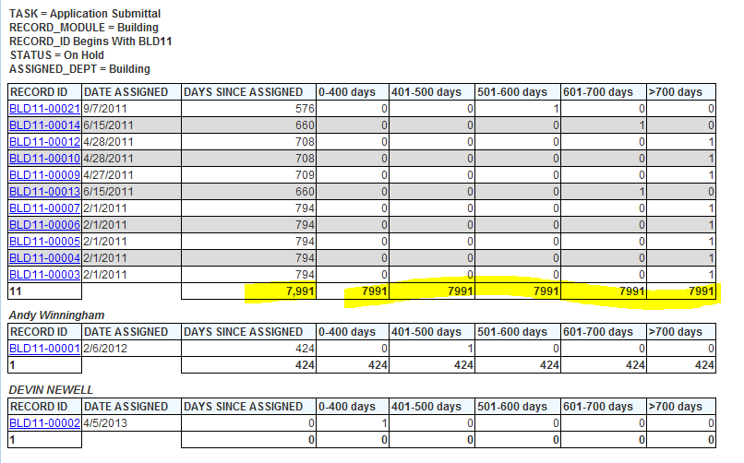

### Value Range - Can't use String range

* Tried the following, all threw error: "Input string was not in a correct format"
  + A to Z:TestString
  + 'A' to 'Z':TestString
  + "A" to "Z":TestString
* This returned no error, but didn't change value:
  + null:No Value
* 0 to 400:0; 401 - 500:1 501-10000:0

## Arithmetic Calculation on Number Fields

1. Basic arithmetic only: Add, Subtract, Multiple, Divide
2. Click in the "A" box for the *second* field to select +, -, *, or '/,
3. Put the label for the calculated column in the *first* field's Description box
4. Example: To divide TOTAL_PAID by TOTAL_INVOICED (to find percentage):



1. Cannot be used if fields in the calculation have Function = Group.
   * This is OK:

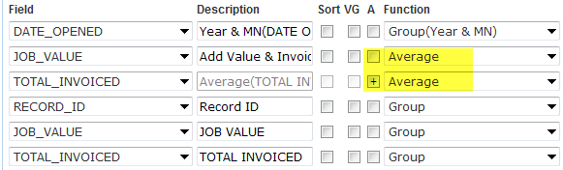

* + This will throw an error when the report is previewed:  
    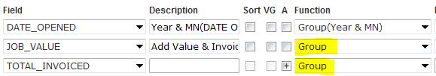

1. Calculations may be performed on more than two number fields. Calculation will follow standard operator precedence, i.e. multiple or division is done before add or subtract.

## Concatenate Two Character Fields

* Click in the "A" box for the *second* field to select +
* Put the label for the concatenated string in the first field's Description box
* Example: To join Inspector first name and last name:  
  
* Result (Izenda automatically adds space between the two fields):  
  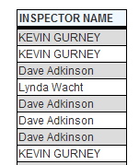
* Cannot concatenate a Character field with a Non-Character field
* Izenda throws an error.

## Data Source, Return To

* To return to Data Source page (to add more views), must have at least one field selected in Fields tab, else Red Forbidden circle appears when you hover over Data Source button

## *Design Form* Button

* Click the Design Form button to launch the *Form Designer* tool. *Form Designer* allows you to create non-tabular reports like forms, letters, permits, notices, etc.
* For help with the *Form Designer* tool, see *Ad hoc Reporting Form Designer Help.docx*

## Form Designer

* See Design Form Button

## Formula Field

* It isn't possible to create a Formula field like in Crystal Reports.

## Function

* Used only for Summary reports, i.e., report shows summary values, no details.
  + Drill-down report may be added to Summary report.
    - See DRILL DOWNS above
* When you specify a function for a field (e.g. Average), all the other fields are automatically given a Group function
* Example:  
  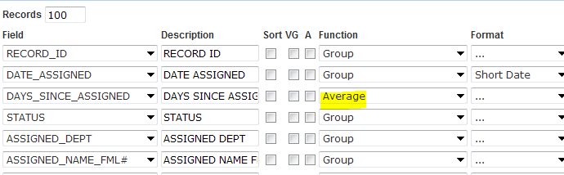
* If function is used on one field, ALL other fields must also use a function

### Functions for Grouping

* For Non-Date Fields, e.g. Character, Number
  + Only **Group** function
* For Date Fields:

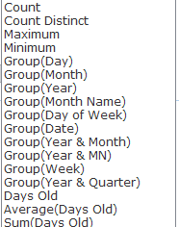

* + Group(Year & Month) = 2013 - 01
  + Group(Year & MN) = 2013 - Jan

### Functions for Aggregation

* 1. For character fields  
     
  2. For number fields:  
     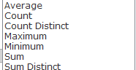
  3. For date fields:





### Group Function to remove duplicate rows

* Use the "Group" function on all fields to remove duplicate rows.  
  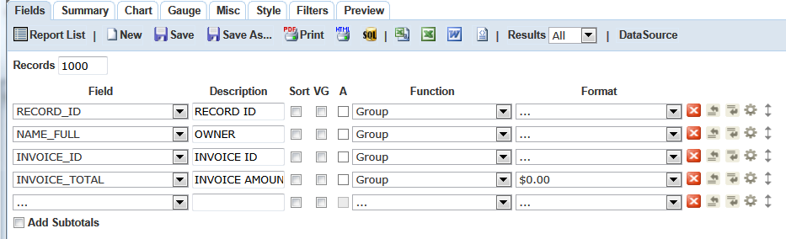
* For example: A report has to use the FEE view to get INVOICE number(s) for each Record. But the report doesn't display fee details, just the invoice number and invoice amount.
* Without the Group function, a duplicate row appears for each fee on the invoice, like this:  
  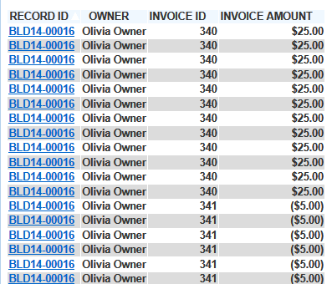
* After the Group function is added for all fields, only one row appears for each Record and Invoice #:  
  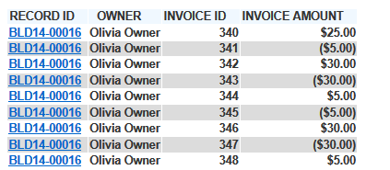

## Grouping - By Date

* You can visually group detail rows by a date element like Year & Month,
* Options under Function dropdown  
  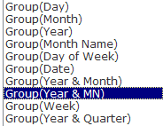
  1. Group(Day) = Day of month
  2. Group(Month) = Month (3 letter abbrev) regardless of Year
  3. Group(Week) = Sunday to Saturday periods. Example:  
     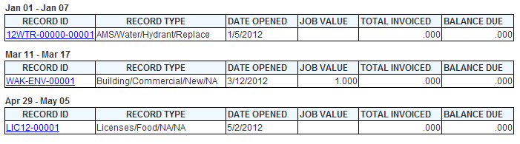

## Grouping - Visual Group (VG)

* To group detail rows by a field, check the **VG** box for the field. The **Sort** box will also be automatically checked:  
  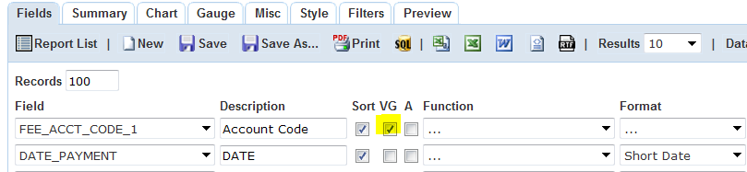
* By default, the Group values appear without any label.
* To add Group Label, go to **Style** tab > **Visual Group Style**. Select one of these options:  
  + **Comma-delimited with Label**  
    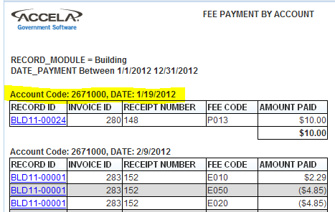
  + **Line-delimited with Label**  
    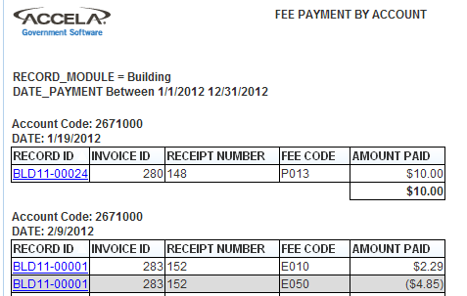
  + **Multi Level with Label.** Like Line-Delimited, but with different font sizes?  
    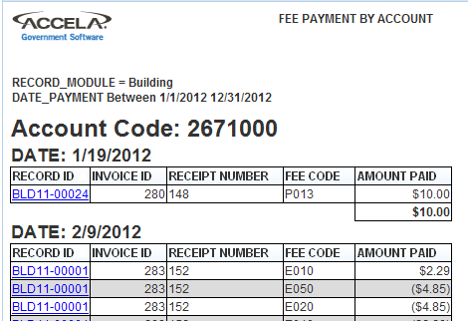

## Quick Add

* Will add all checked fields to report in alpha order

## Records field

* The Records fields limits the number of rows the query will return and which the report will display  
  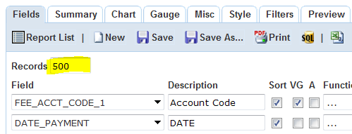
* If only aggregated values are shown, the Records count is the number of aggregated rows. The query groups and aggregates values in an inline view, and the specified # of rows (Records) are pulled from the inline view
  + Example

SELECT * FROM

(

SELECT

"ACCELA"."V_INSPECTION"."INSPECTION_TYPE" AS "INSPECTION TYPE", COUNT("ACCELA"."V_INSPECTION"."INSPECTION_ID") AS "Count(INSPECTION ID)"

FROM "ACCELA"."V_INSPECTION"

WHERE ( ("ACCELA"."V_INSPECTION"."DATE_SCHEDULED" BETWEEN @TO_DATE('2010-01-01 00:00:00', 'YYYY-MM-DD HH24:MI:SS') AND @TO_DATE('2013-12-31 23:59:59', 'YYYY-MM-DD HH24:MI:SS')) AND ("ACCELA"."V_INSPECTION"."DISPOSITION_STATUS" = 'Insp Scheduled') ) AND (("ACCELA"."V_INSPECTION"."AGENCY_ID" = 'IMPREF'))

GROUP BY "ACCELA"."V_INSPECTION"."INSPECTION_TYPE"

)

WHERE ROWNUM <= 1000;

## Rows Returned by Query - Setting

* To set the number of rows that the query returns, enter the number of rows in the **Records** field:  
  
* The SQL statement adds a rownum limit:  
  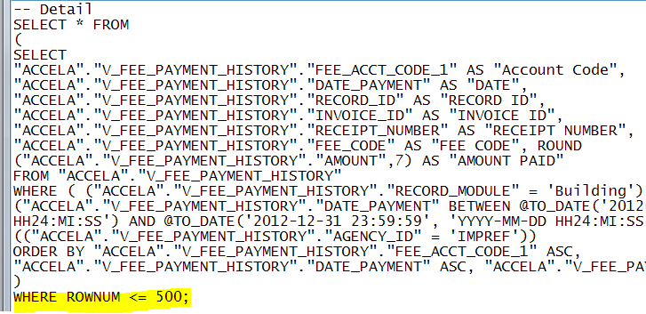
* If the **Records** field is empty, the query sets a limit of 100,000 rows returned

## Sort checkbox

* Sorts in ascending order, by default
  + To sort by descending order, click ***Gear*** icon > check **Sort z-a**
* Can sort by multiple fields
  + Sort order is determined by position of field - Higher fields are sorted first  
    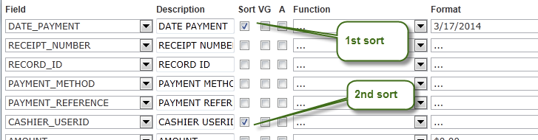

## Subtotals / Add Subtotals

* When the **Add Subtotals** box beneath the list of fields is checked:
  + If VG (visual group) box is checked for one or more fields, subtotal(s) are added for each group. No grand totals are added.
  + If no VG box is checked, total(s( are added for the report.
* Subtotals (for Visual Groups VG) are automatically **summed** for all fields with **number** data type.
  + Example. A subtotal is automatically added for INVOICE ID field because it has a numeric value.  
    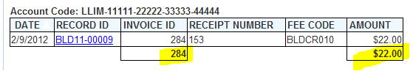
  + However, if all subtotaled values are null for a Visual Group, no subtotal appears. Example:

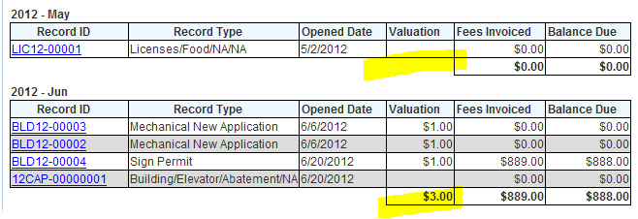

* It’s not possible to sub-total on a field used for Visual Grouping (VG)
* See also: *Grouping – Visual Group (VG)*
* To manually add a subtotal to a field, click on the **Gear** icon (Advanced Field Settings) to the right of the field. In the Subtotal Function field, select the appropriate subtotal function from the dropdown. The dropdown options vary depending on the field’s data type.
  + Example of Subtotal Function dropdown options for a text field:  
    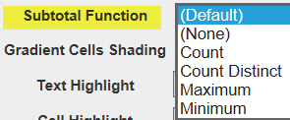
* To remove an unwanted subtotal (e.g. for Invoice ID, Receipt ID), click on the **gear** icon (Advanced Settings) to the right of the field. In **Subtotal Function** field, select (None)  
  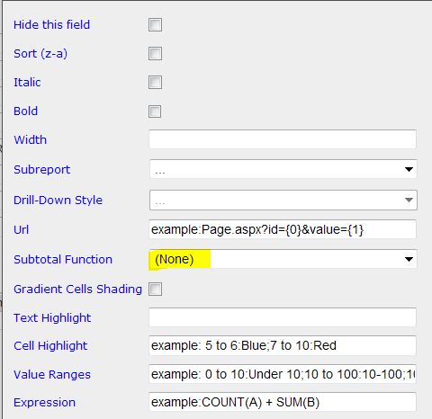

## Total, Grand

* To add field's grand total to report, use **Summary** tab.

## VG checkbox



* See above: **Grouping - Visual Group (VG)**

# FILTERS tab

## Blank checkbox

* means "OR this field (not parameter value) is null"
* Example

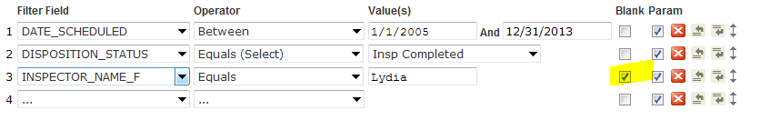

WHERE clause - relevant code:  
(("ACCELA"."V_INSPECTION"."INSPECTOR_NAME_F" = 'Lydia') OR ("ACCELA"."V_INSPECTION"."INSPECTOR_NAME_F" IS NULL OR TRIM( TO_CHAR("ACCELA"."V_INSPECTION"."INSPECTOR_NAME_F")) IS NULL )) )

* --> produces this query  
  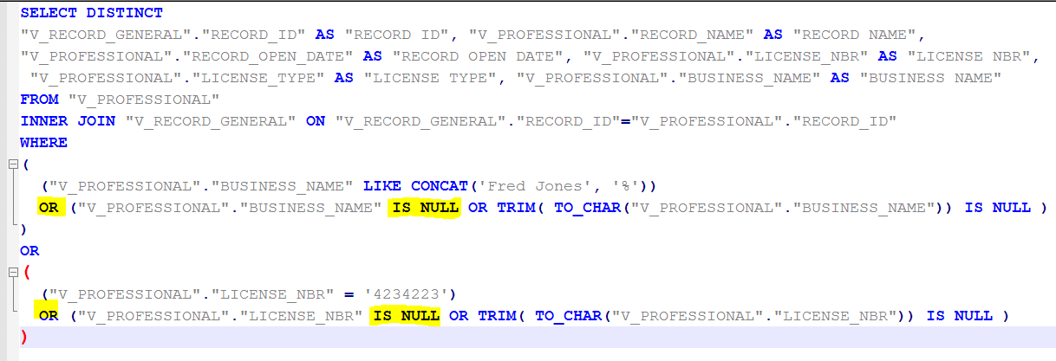

## Date Filters

### “In Time Period” operator

* Only appears for Date fields. Note that ASI dates aren’t recognized as Date fields)
* If “In Time Period” operator is selected, further dropdown options appear:  
  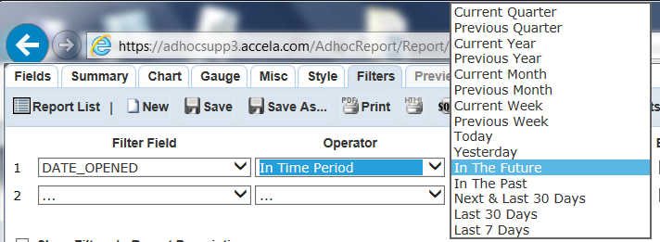

### Selecting Future Dates

* To pull Records with a date which occurs on a date that is a specific # of days in the future, use the **Equals Days Old** operator with the specific # of days in the future as a *negative* number.
* To pull Records with a date which occur within a specific # of days in the future, use the **Greater Than Days Old** operator with the specific # of days in the future as a *negative number*.
* See examples below.

### Examples:

#### Find licenses that will expire exactly 30 days from today:

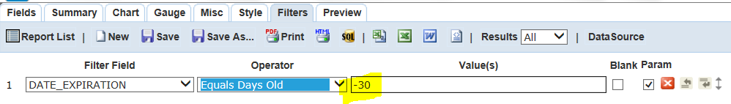

#### 

**Resulting SQL query:**

AHR calculates the future date and uses it with an EQUAL operator in the WHERE clause:

SELECT

"ACCELA"."V_RECORD_LICENSE"."DATE_EXPIRATION" AS "DATE EXPIRATION", "ACCELA"."V_RECORD_LICENSE"."RECORD_ID" AS "RECORD ID"

FROM "ACCELA"."V_RECORD_LICENSE"

WHERE ( ("ACCELA"."V_RECORD_LICENSE"."DATE_EXPIRATION" = TO_DATE('2015-10-31 00:00:00', 'YYYY-MM-DD HH24:MI:SS')) ) AND (("ACCELA"."V_RECORD_LICENSE"."AGENCY_ID" = 'MDARD'))

#### Find licenses that will expire between tomorrow and 30 days from today:

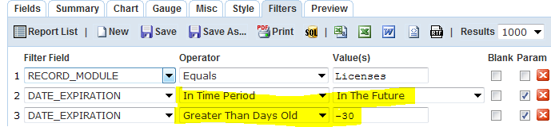

Use Negative Number for **Greater Than Days Old** value to find future dates.

### Date Range Filters - To Work in Report Manager

* Report Manager needs date range filter to be two parameters: Date From, Date To.
* Instead of using the "Between(Calendar)" operator, create two filters in AHR and use comparison operators of "Isn't Less Than" or "Isn't Greater Than", which mean "Greater than or equal to" and "Less than or equal to" respectively.
* You must set Filter Logic to use “**AND”** between all the filters. If not done, AHR uses OR for the two date filters, which gives incorrect results.
* See Community post: [**RE: ad-hoc report set up in report manager**](http://community.accela.com/accela_automation/f/37/p/4348/11564.aspx#11564)

### Filter Logic and Two Date parameters

#### Tested in Oakland Prod

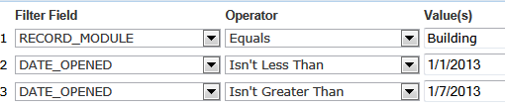

**Note**: AHR puts in OR by default between the two DATE_OPENED filters.

Resulting SQL query:

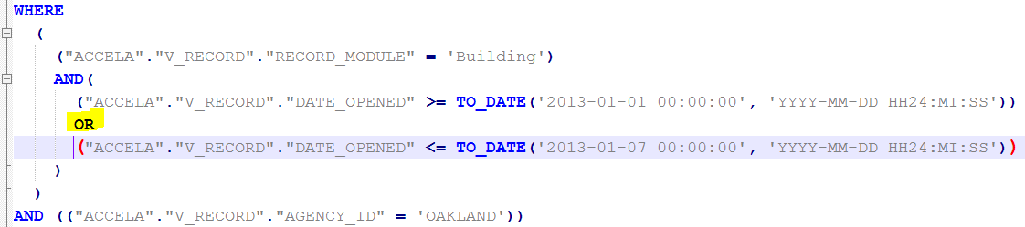

* + This logic is not desired. The query pulls Records that meet EITHER of these criteria:
    - Opened on or after 1/1/2013
    - Opened on or before 1/7/2013.
  + That is, the query pulls ALL Records in the database, regardless of Opened Date, because every single record is either opened before 1/7/2013 or opened after 1/1/2013.
  + To correct this default behavior, you must use the Filter Logic field to specify “AND” logic, not “OR” logic.

After adding **Filter Logic** to explicitly use “AND”:

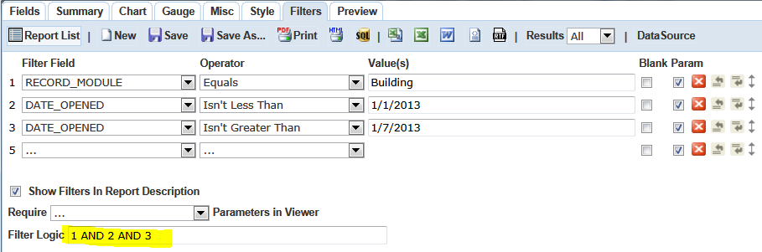

Query works correctly OK now-->

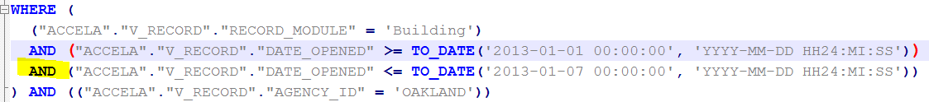

Query now correctly pulls Records opened between 1/1/2013 and 1/7/2013.

## Multiple filters – how AHR applies the filters

* Defaults to 'AND' on all parameters – i.e., all filter critieria must be met
  + An exception is when the SAME field is used in MULTIPLE filers: AHR uses OR between the field's filter criteria. To over-ride this, specify "AND" in Filter Logic. Example:

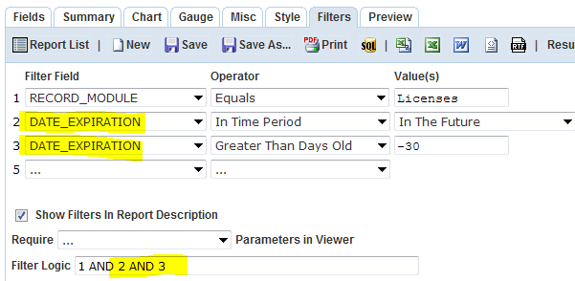

* If one of the parameters is empty (i.e., has no Value), that parameter is excluded from WHERE clause altogether

## Operator

### Blank

* Where Field value is NULL (Oracle or Sql Server) or is empty string (Sql Server)
* Must check "Blank" for filter that applies to outer joined table.
  + Example: Show Record data and name of "Tenant" contact type. If there is no "Tenant" contact type, Record data should still appear.
  + RECORD is left joined to CONTACT  
    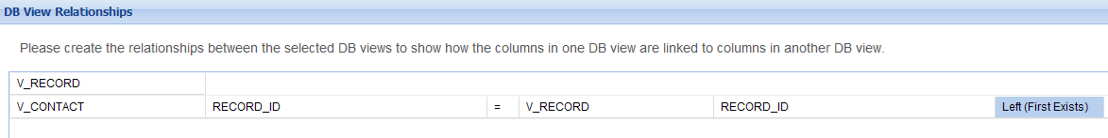
  + Add filter: CONTACT_TYPE = Tenant, and check "Blank" box  
    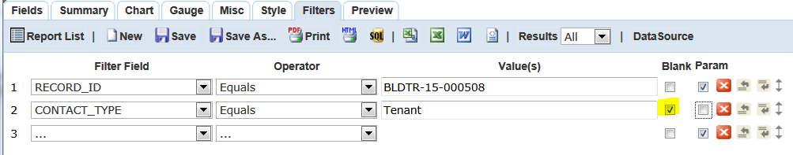
  + If Blank box isn't checked, the LEFT OUTER JOIN won't work, i.e., if Record doesn't have contact type of "Tenant", no Record data appears at all.

### Equals (List)

* Allows you to enter a list of values, each on separate line. Alternatively, separate each value with a comma (with or without space). ~~Don't use comma or other separator.~~
* Resulting WHERE clause uses IN (comma separated list ). Example:  
  WHERE ( ("ACCELA"."V_ADDRESS"."STATE_" IN ('TX','CA')) ) AND (("ACCELA"."V_ADDRESS"."AGENCY_ID" = 'IMPREF'))
* Such a parameter can be configured in Report Manager as "Drop-down List" parameter type.
* Buggy when values have spaces:
  + Equals (List): Final CO Issued,Temp C of O Issued 🡪  
    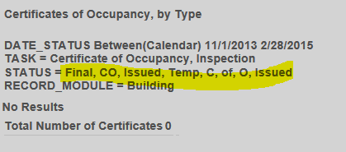
  + If one multi-word value – OK.
  + If one multi-word value and a single word value – OK
  + If two multi-word values – tool adds commas between ALL words!!

### Equals (Pop-up)

* Presents a pop-up window with distinct values to select as checkboxes

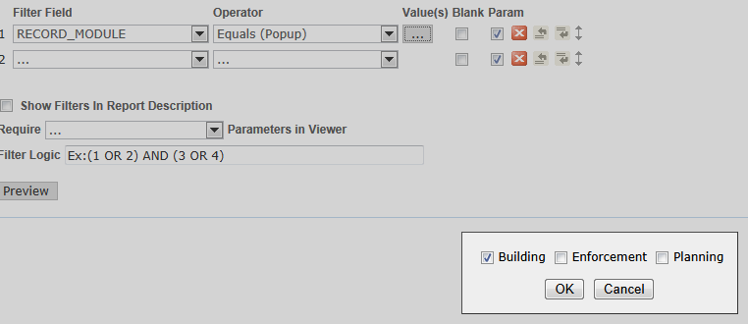

### Equals (Select)

* Dropdown values automatically populated from View
  + If table has a lot of rows, dropdown may take long time to populate
  + The SELECT DISTINCT operation to find dropdown values may hit DB quite heavily. If this is used a lot, may impact DB performance.
  + The tool automatically filters a parameter’s dropdown values based on the filter values above it (prior to it).
* User can select 1 value

### Equals (Multiple)

* Dropdown values automatically populated from View
  + If table has a lot of rows, dropdown may take long time to populate
  + The SELECT DISTINCT operation to find dropdown values may hit DB quite heavily. If this is used a lot, may impact DB performance.
  + The tool automatically filters a parameter’s dropdown values based on the filter values above it (prior to it).
* All options appear by default. Example:  
  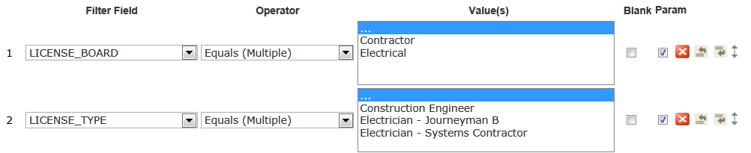
* User can select 1 or more values

### Like

* Wildcard operator = %

## Parameters - Optional

* parameters appear to be always Optional (cannot specify as Required??)
* If there are 2 parameters and criteria is that one or the other is true, do NOT use "OR" filter logic -- this will pull ALL rows. Use "AND" Filter Logic instead - because if a parameter is blank, the SQL is   
  
  + Side note: CONCAT function only available in SqlServer 2012

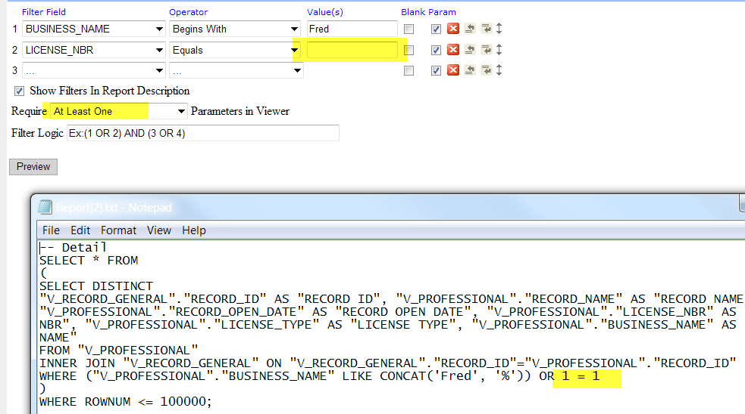

What the ?

==---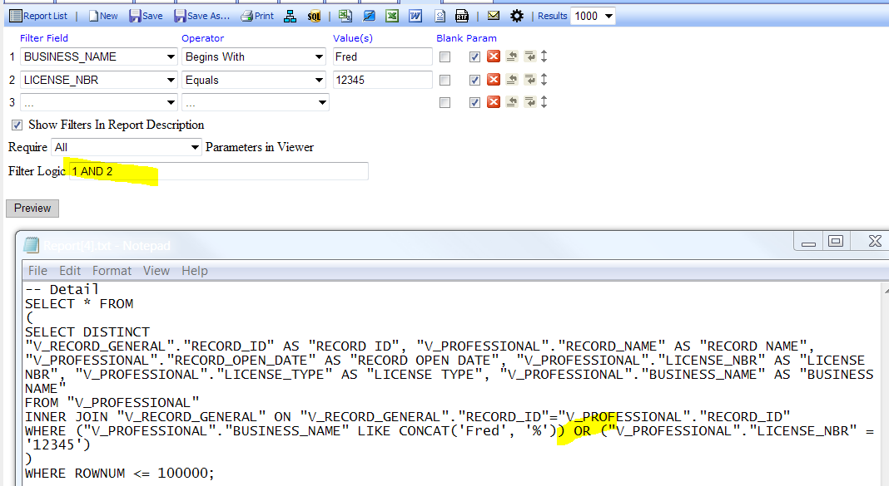

## Value(s)

* If the value for a filter (or parameter) is left blank, report query ignores the filter/parameter (i.e. filter isn’t included in WHERE clause)
* However, if “Show Filters in Report Description” is checked on Filters tab, all filters appear with … , regardless of whether value was supplied for filter
  + Example:  
    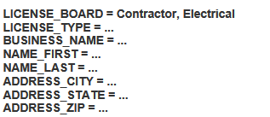

# Layout Help

## Column Headings

* In PDF: Column headings repeat on every page
* In Excel: Column headings don't repeat on every printed page

## Grouping columns under their own heading

(example screenshot below) See Column Group



# Logo (Global)

* A logo image appears on the top-left of every tabular report (and all embedded tabular subreports, if used). If the agency doesn't upload a logo for AHR, AHR uses the Accela logo by default.
* For more information on configuring an agency-specific logo, See *Ad hoc Reporting - Admin Help.docx*

# MISC tab

## Report Header Image Justification

* Determines whether the logo at the top of the report is aligned to the left margin (L), to the right margin (R), to the center (M), or is removed from the report (empty checkbox).
* Click the box to the right of **Report Header Image Justification** to cycle through the options. The options are:
  + L Left align
  + R Right align
  + M Center (Middle) align
  + *Empty* Logo does not appear
* Note the when choosing “M” to center the logo in the middle of the page, the logo may not be properly centered if report filters or report title are displayed.
  + Logo centered at top of the report

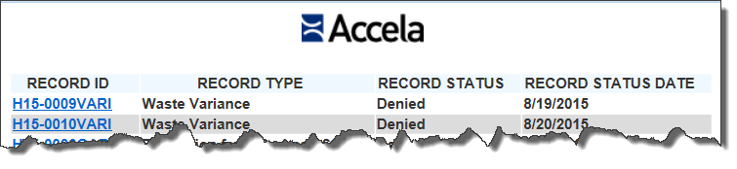

* + “Centered” logo is offset to the right when Filters are displayed. (The report filters appear at the top of the report if **Show Filters in Report Description** is checked on the **Filters** tab.)

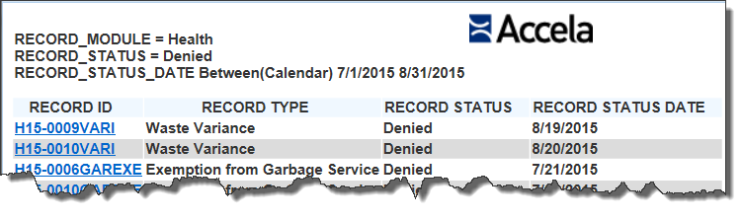

* 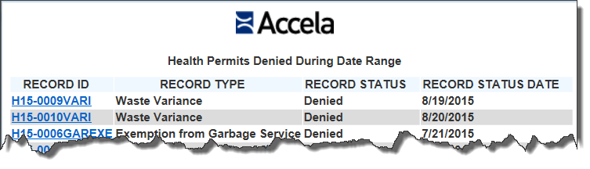

## Title

* Report Title
* Cannot specify font / font size / bold / italic
  + In PDF, Title is large: Tahoma 20 points
  + In Excel, Title is same size as Description and Parameters: Calibri 10pt
* Can specify alignment using the box the right of the Title. Options:
  + L = Left align
  + R = Right align
  + M = Middle (center) align
  + *blank* ***=*** Don’t display Title
* Click on the L in the box to cycle through the options above.
* Default alignment is Left (L).



* **Only one row of text**. Cannot insert line break.

## Description

* Report subtitle - appears below Title, above Parameters
* Can specify alignment: Left, Middle, or Right
* Cannot specify font / font size / bold / italic
  + In PDF and Excel, Description is same font/size as Parameters (10pt normal)
* **Only one row of text**. Cannot insert line break.

## Header

* Report Header - Appears immediately above Logo, **on top of 1st Page Only**
* Can specify alignment: Left, Middle, or Right
* Cannot specify font / font size / bold / italic
  + In PDF, in grey color Tahoma 10pt, e.g. IMPREF AGENCY - LYDIA'S REPORT
  + In Excel, same font/size as Title, Description and Parameters: Calibri 10pt
* Multiple lines of text may be entered.
* In PDF, appears below Date/Time, Page # (if used):  
  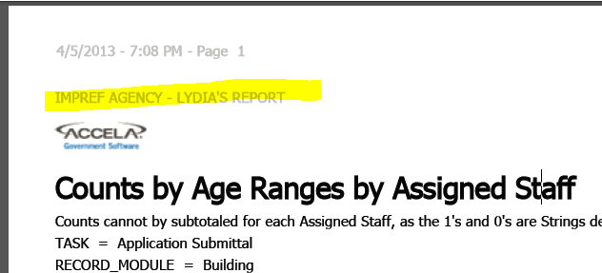

## Footer

* In PDF, is Page Footer - appears at **bottom of every page**
  + In grey color, Tahoma 10 pt, e.g. PRIVATE AND CONFIDENTIAL (NOT)
* In Excel, is Report Footer - appears at the **bottom of the last print page**
  + Insame font/size as Title, Description and Parameters: Calibri 10pt

## Share With

* Used to set permissions or access to report
  + Cannot be over-written by Report Manager settings
* By default - **Everyone - Full Access**
  + This means everyone can run AND edit the original report  
    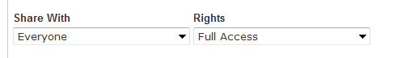
* Rights = **Read Only**
  + To allow others to run, but not Save (edit) original report (Save As is ok)
  + Other uses can click Design button from the Report Designer Toolbar, but Save button is greyed out
  + Other users can delete report (!) – observed at MA BPT, Dec 2014
    - Even after clearing cache
* Rights = **View Only**
  + Report may be run by others, but not edited, Saved, or Saved As
  + Design button not available
  + Other users can delete report (!) – observed at MA BPT, Dec 2014
    - Even after clearing cache
    - Worked correct the next day (?)

# Output

## Deep links

* Deep links broke with AA 8.0??
  + Observed on av.supp, WASHOE agency, 10/10/15
  + Link includes a 5443 port #, which appears to not work. URL works when 5443 is removed.
* A deep link allows a report user to direct open the specified Record (or item) in Accela Automation by clickin on its ID. Links are automatically added to these fields:
  + RECORD_ID
  + INSPECTION_ID
  + PARCEL_REF_ID
  + CONTACT_REF_ID
* Deep links aren't added to:
  + RECEIPT_ID
  + PAYMENT_ID
  + FEE_ID
  + PARCEL_NBR

## Deep Link - Reference Contact ID

* Deep link automatically added for CONTACT_REF_ID field:  
  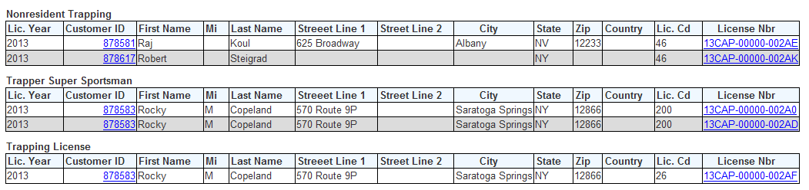
* Clicking the link brings up the Reference Contact form:  
  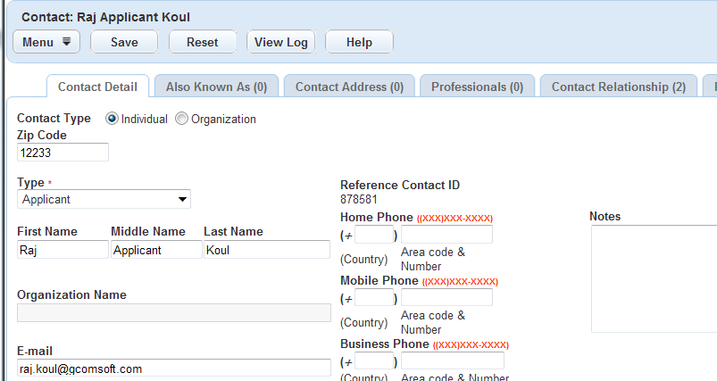

## Deep Link - Inspection ID

* Deep link automatically added for INSPECTION_ID field
* Clicking the link brings up Inspection Detail portlet only in pop-up window:  
  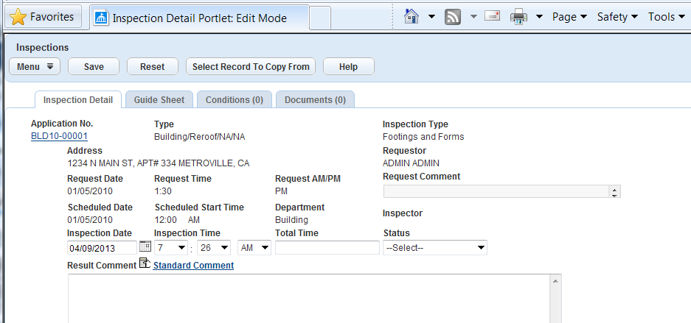
* URL Example (IMPREF agency):

## Deep Link - Record ID

* Deep links automatically added for Record ID:  
  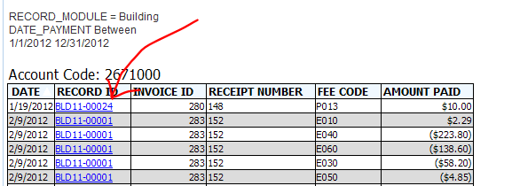
* This will bring up a separate pop-up window containing the Record and all its tabs:  
  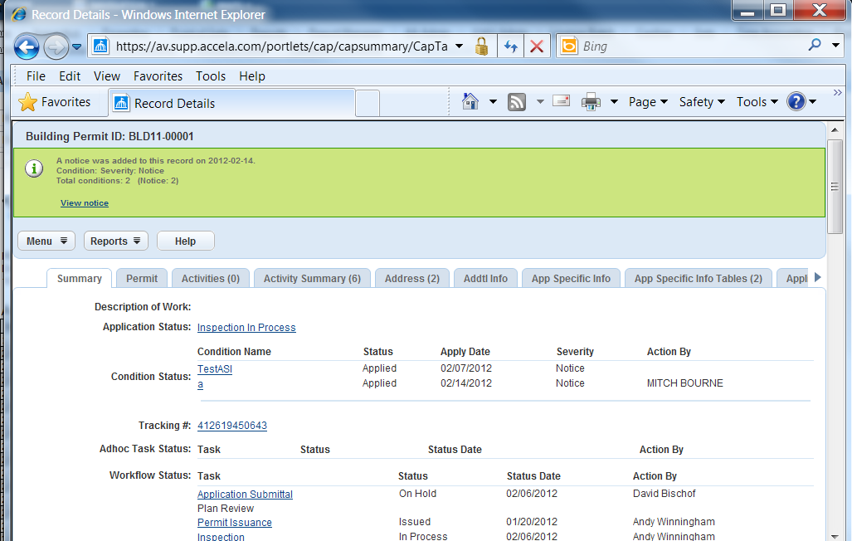

OR, if user had just been on a specific portlet, clicking on another Record ID link will open the Record in the same portlet.

* This is coded by default to the Record ID field's **Advanced Settings** (in **Fields** tab):  
  NOT always? Don't see this URL in 4/9/13 test in IMPREF   
  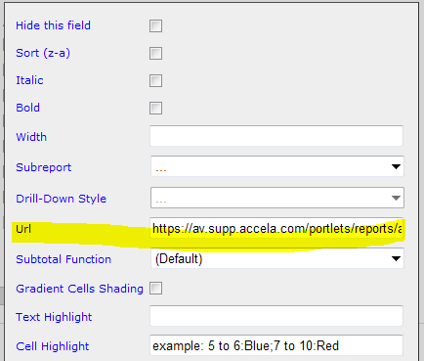
* Deep link is NOT exported in PDF or Excel. Though in PDF, the Record ID values are blue and underlined, but aren't hyperlinks.
* Example URL for Record ID BLD11-00025 link (IMPREF agency):



WASHOE agency 10/10/15: Deep link doesn’t work because of 5443 port – when removed, works

https://av.supp.accela.com:5443/portlets/reports/adHocReport.do?mode=deepLink&reportCommand=recordDetail&altID=H15-0009VARI

## Logo (Global)

* A logo image appears at top of every report. If the agency doesn't upload a logo, AHR uses the Accela logo by default.
* To upload a logo to be used instead of the Accela logo on all AHR report: See AA 7.3 Administrator Guide page 255: **Applying a Logo to Ad Hoc Reports**
  + Configure the Standard Choice LOGO_TYPE_CATEGORY to include the Standard Choices

Value AGENCY_LOGO.

* + Go to: v360 Admin > Agency Profile > Logos > New. Select Logo Type of AGENCY_LOGO. Upload the Logo image file and click Save.
* The Global Logo cannot be removed. It appears in all reports and subreports, including embedded subreports.
  + Workaround to remove logo: Upload a blank PNG image file as the AGENCY_LOGO, making it small in size. Example:  
    
  + See Steps above for uploading.

# Report Manager

See ~~Report Manager Integration folder >~~ *Report Manager and Ad Hoc Reporting Help.docx*

# PREVIEW tab

## Interactive sorting

* Click on any column label to sort ascending/descending.
* Help text describes this at bottom of preview screen:  
  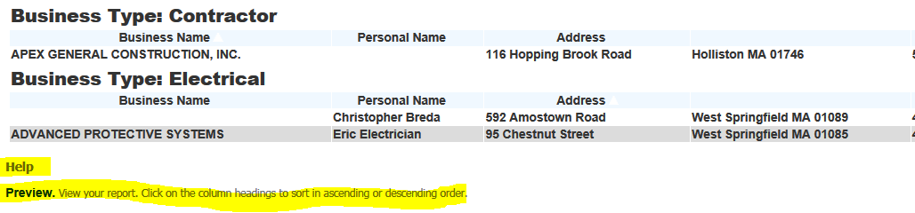

# STYLE tab

## Border Color

* Specify a color (e.g. black) so that data appears within gridlines:  
  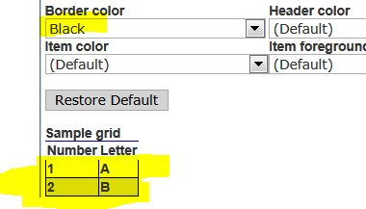
* **NOTE: This is buggy!!** If gridlines are used, report data disappears when exported to PDF or when report is run from AHR report menu. Report only works correctly when run from Preview tab in design mode.

## Add bookmark for each visual group

* Works for PDF output only: Adds bookmark for each visual group. Bookmarks by group field values (truncated!):  
  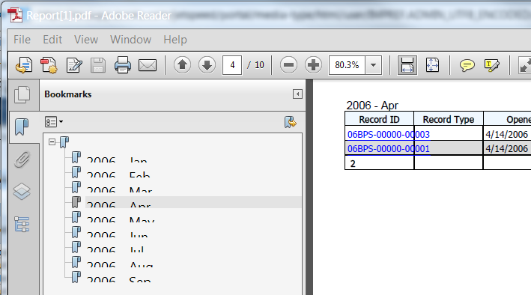
* Doesn't work in Excel or Word

## Landscape Printing

* Controls whether PDF output is in portrait or landscape orientation.
* If not checked, PDF output is in portrait orientation.
* PDF output defaults to Letter-size paper

## Page Breaks After Visual Groups (PDF)

* Works for PDF output only, adds a page break after each Visual Group

## Show Date and Time

* Checked by default
* Cannot specify font/style/size/color, or alignment, or position on page (top/bottom)
* Date and Time appears at top of every page in PDF, in grey, e.g. 4/5/2013 - 7:31 PM - Page 1
* Doesn't appear in Excel

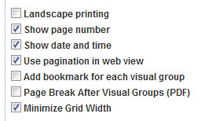

## Show Page Number

* Checked by default
* Cannot specify font/style/size/color, or alignment, or position on page (top/bottom)
* Page 1 appears at top of every page in PDF, in grey, preceded by dash e.g. - Page 1  
  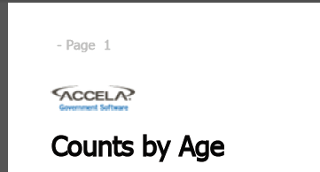
* Doesn't appear in Excel

## Show Summary Report in Field Value Style

* Each row will show [Column1 Label] [tab] [Column1 Value][tab][Column2 Label] [tab] [Column2 Value][tab][Column3 Label] [tab] [Column3 Value]... etc.
  + This will wrap if the row exceeds page width
* Example of 3 Column Summary (*Minimize Grid Width* is Checked in **Style** tab)  
  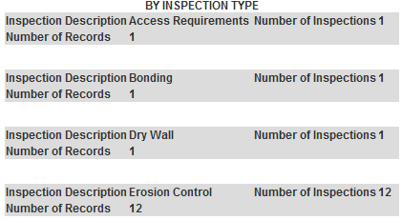
* Example of 3 Column Summary (*Minimize Grid Width* is NOT Checked in **Style** tab)  
  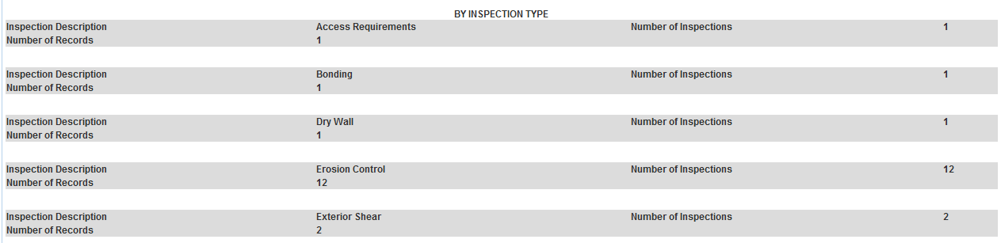

## Minimize Grid Width

* Is checked by default
* If Checked:
  + In screen output: Column width is the just wide enough to fit Column Label without wrapping (Column Width is not specified in Field's Advanced Settings)
  + in PDF: "Minimize Grid Width" causes columns to be narrow with overflow issues  
    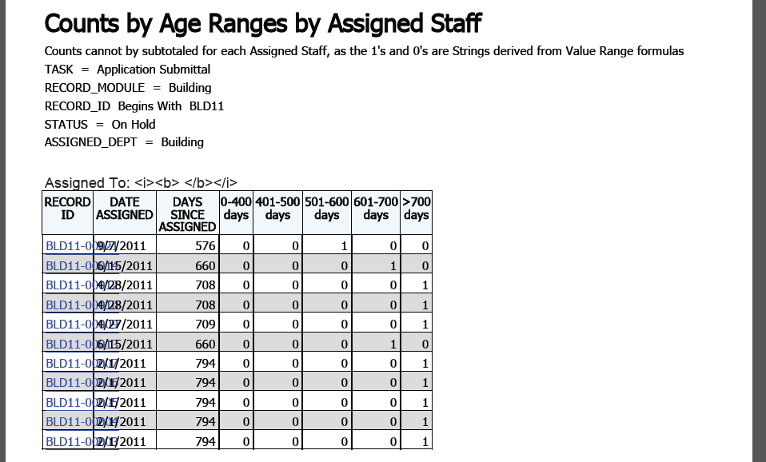
* If Not Checked:
  + In Screen Output: Columns/Table expand to fit width of page.
  + In PDF: If "Minimize Grid Width" is unchecked, table/columns expand to fit width of page:  
    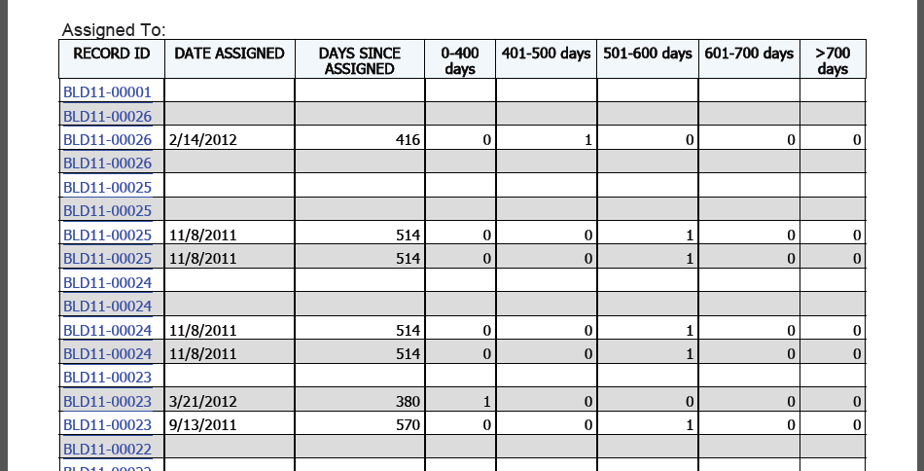
    - Columns don’t always expand in PDF to fit width of landscape page even if “Minimize Grid Width” is unchecked. Observed at MA BPT, Dec 2014.
  + In PDF, if **Style** for **summary** section is 

The field and value pair is too far apart. Example in PDF:  
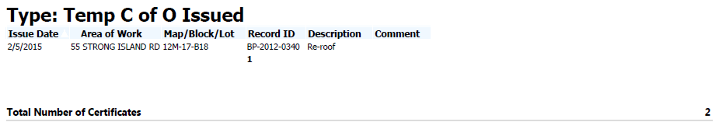

If Minimize grid width is checked:  
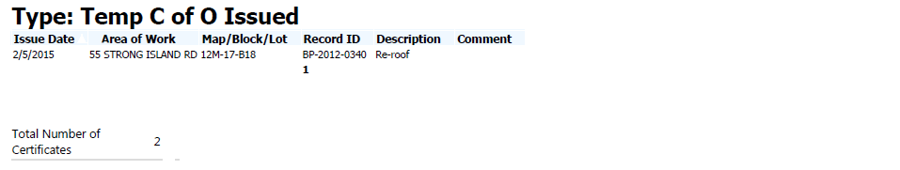

* In Excel export – similar rendering of Summary field-value pair

## Visual Group Style

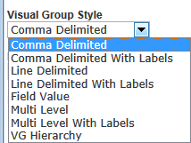

* Comma Delimited (default)
  + Group Value (no label) appears at top of grouped rows
  + If multiple VG are checked, the group values (no label) are displayed in one line, separated by comma
* **Comma-delimited with Label**  
  
* Line Delimited With Labels:
  + 
  + Example with two VG fields (Record Type, Record Status):  
    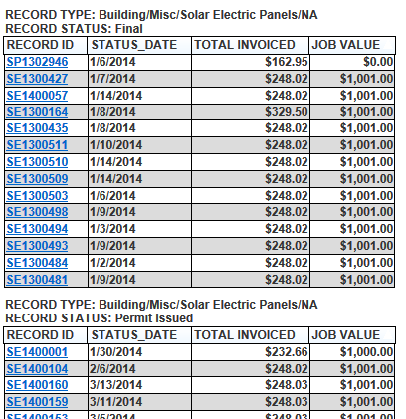
* **Multi Level with Label.** 
  + 1st group heading appears once, larger
  + 2nd group headings appear for 1st group heading  
    

# SUMMARY tab

## Total (Grand Total, Report Total)

* To add a field's grand total to the report, go to **Summary** tab and add the field. Choose Sum.
* The total appears at the beginning of the report, by default. To move it to the end, go to Style tab > Report Order. Click the **Down** arrow to move **Summary** below **Detail**.
* By default, the Total value appears in a box, with the label above and value below. Example:  
  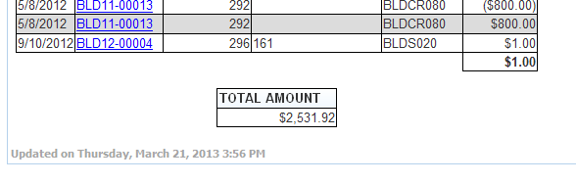
* Example with two fields:

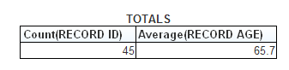

* To make the label and value appear side by side, go to **Style** tab. At the bottom, check "Show Summary report in Field | Value style".  
    
   Example:  
  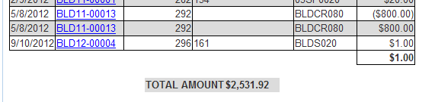
  + Example with two fields:



### Alignment / Justification

* Gear icon > Label and Value Justification don’t appear to work, whether in preview or when exporting to PDF/Excel. Always defaults to L justification. If Style > Minimize Grid Width is unchecked, justification still doesn’t work, but tool places Label on left edge of page, and pushes value to the right edge of page!

## Subtotals

* To display the group subtotals, plus report totals, in the report's Summary section:
  + Add field to group by. Under **Function**, select Group. Move field to top of list.
  + Add fields to Subtotal and Total by. Under **Function**, select the type of summary (e.g. Sum, Count, Average)
  + Example:

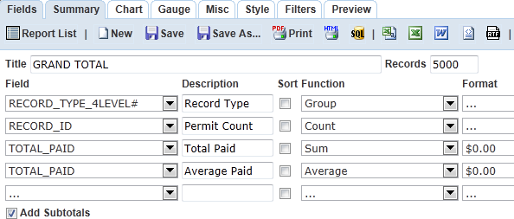

Resulting summary:

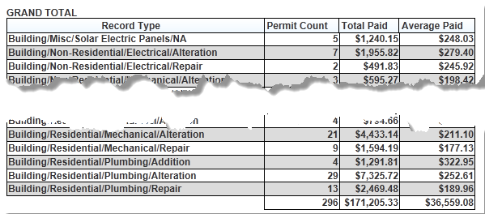

# TEMPLATES (ASI, TSI, Custom Attributes)

* Feature released in 7.2 FP2 Hotfix 7 (Jan 2013)
* Needs minimum Oracle 11g or SQLServer 2005 to work
* Pull in ASI, TSI, any custom attribute field.
* ASIT templates available in 7.3
* If a view has ASI, TSI or custom attribute associated with it, an icon appears for it under the *Templates* column in the **Data Sources** tab:
* 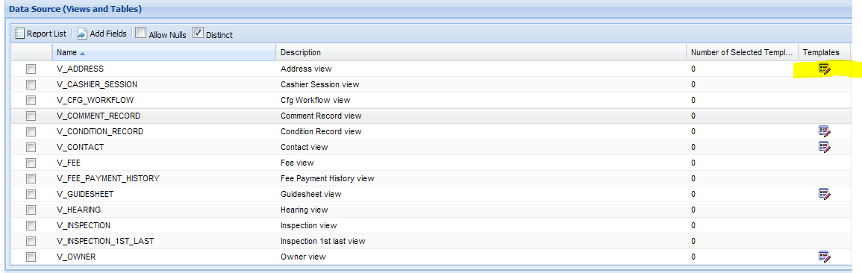
* Click the icon to bring up the ASI Groups or APO Templates associated with that view. Example:

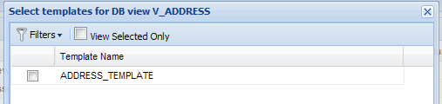

* Check the box(s) to select the template(s) and click Submit
* No need to add joins (automatically done as outer join)
* In the **Fields** tab, the selected Template and its member fields appear in the *Fields* dropdown. Example:  
  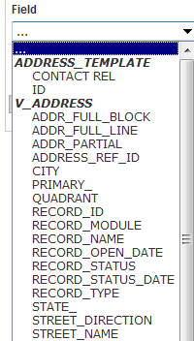

## Cannot filter by ASI Date or Number

Community post > Reporting > 10/22/2015

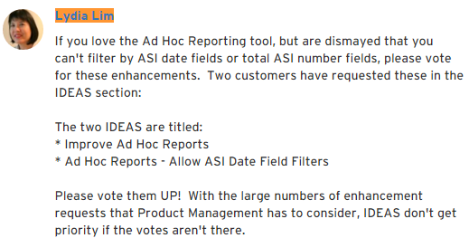

# TEMPLATES - ASIT (AA 7.3)

## Adding ASIT to report

* On Data Sources page, Click on **Template** button to the right of the V_RECORD view. Template Selector pops up.
* To find ASIT template, click Filters and enter ASIT table name in "Template Name" field. Example:

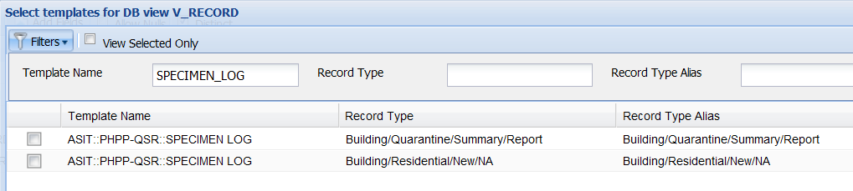

* + Check the item and click Submit
* In Fields tab, the ASIT and its columns appear in dropdown list for fields:  
  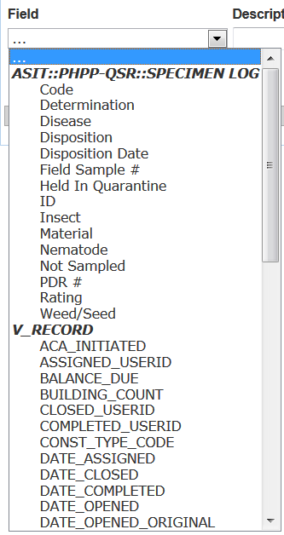
* For fields outside ASIT (e.g. Record ID, Description, Record Status, etc.), use VG (Visual Grouping) . In **Style** tab, set Visual Group Style to "Line Delimited With Labels".
  + Example:  
    **Fields** tab:  
    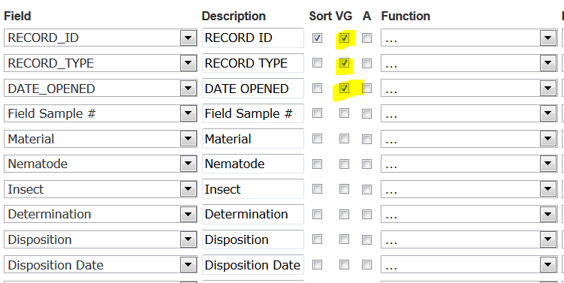  
      
    **Output**:  
    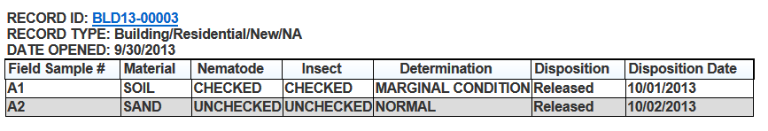

## Guidesheets ASIT not available

* V_GUIDESHEET view doesn't support ASIT, only ASI. Per Engineering 14ACC-04712 on 5/14/2014
* ASIT associated to Guidesheets don't appear in Templates Selector pop-up. Only the ASI subgroups appear.
* See C:\Working Folder 101103\Izenda Ad Hoc Reporting Tool\Issues & Limitations\ASIT doesn't appear for V_GUIDESHEET in Template Selector

# Toolbar (aka Report Designer Toolbar)

The same menu bar appears for every tab:  


## Results

* Not sure what this controls.

## Export options

* **CSV**
  + Comma separated values.
  + Parameter values not exported
  + When opened in Excel:  
    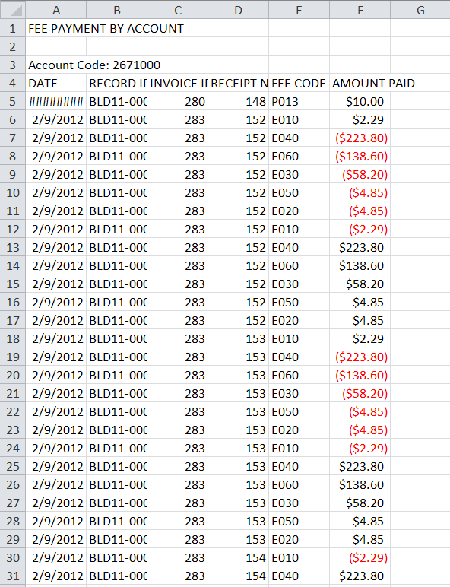
* **PDF** 
  + Click Print button
  + PDF export is not pretty.
    - Column widths don't expand to fit data, so that contents overflow into next column
    - Subtotal row is ugly
    - 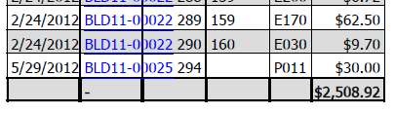
    - Grand Total is even worse:  
      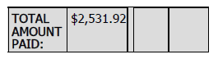

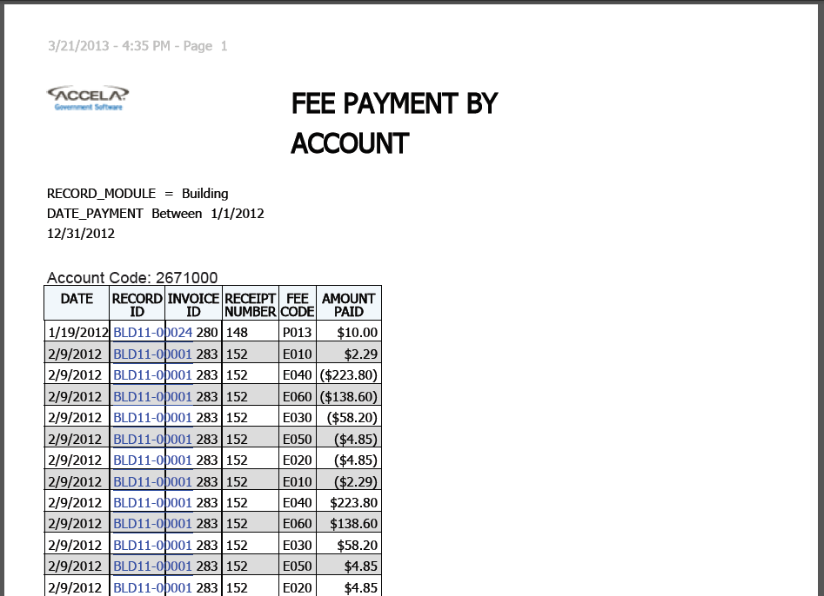

* **Microsoft Excel (MIME)**

Output is better than PDF, though centered report title is too far to right  
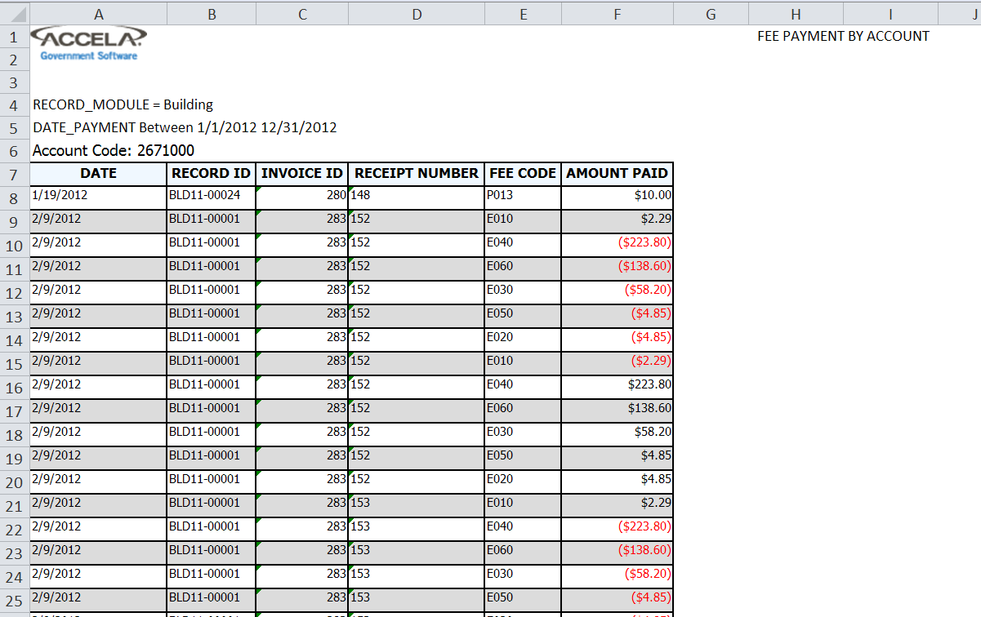

# User Guides, Links

1. Izenda training videos, lessons, user guides: <http://www.izenda.com/site/kb/Training/78>
2. Accela Automation 7.2.0 FP2 User Guide -pg775

# ERRORS HELP

## Error msg on Data Source page: Please fill in all the fields in the relation building panel... But all joins have been added

**Fix**: Click outside dropdown for the last join added

## Cannot Add Fields after selecting data source. Error appears after clicking “Add Fields” : System error. Please contact the administrator for help.

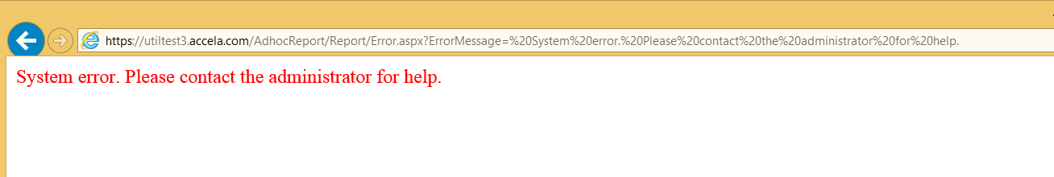

All reports also disappeared from reports list (menu).

Observed at MDARD on TEST3 (Oct 2015) after converted data was loaded and config restored from SUPP3 into TEST3.

**Possible Fix**: Go to Report Manager > Settings > Ad Hoc Report data Sources. Select V_RECORD, delete and re-add its permissions. That seemed to reset whatever discrepancy was causing the error.

## All reports disappeared from reports list

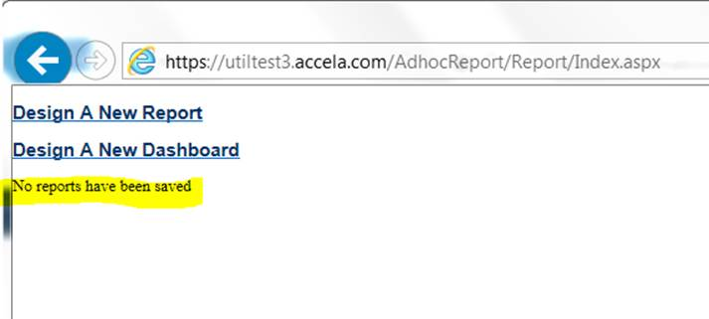

There should’ve been a few dozen. Observed at MDARD on TEST3 (Oct 2015) after converted data was loaded and config restored from SUPP3 into TEST3.

**Possible Fix**: Go to Report Manager > Settings > Ad Hoc Report data Sources. Select V_RECORD, delete and re-add its permissions. That seemed to reset whatever discrepancy was causing the reports’ disappearance.

# BUGS / ISSUES

1. Embedded subreport no longer works. Throws error in Preview:   
   

# HOW-TOs

## Remove duplicate rows

* In the Fields tab, use the Group Function on all fields.
* See Group Function to remove duplicate rows